Unfitness to be tried/to plead

Last Update: October 2023

Contents

A. Introduction 1

B. Unfitness to be tried: Section 20B of the Crimes Act – Matters to be heard on indictment 2

Stage at which the question of fitness is raised 3

Procedure where fitness to be tried is raised at the committal stage 3

Procedure where fitness to be tried is raised post-committal 4

Threshold test 4

Subsequent fitness hearing 4

The meaning of ‘to be tried’ 4

Expert evidence 5

Onus of proof and standard of proof 5

Federal procedure following a finding of fitness or unfitness 6

Requirement of a *prima facie* case 6

Procedure following *prima facie* determination 7

Recording outcomes in CaseHQ 7

C. Summary disposition of persons suffering from mental illness or intellectual disability: Section 20BQ of the Crimes Act 7

Orders the Court can make 10

The meaning of ’treatment’ in section 20BQ(1)(c)(ii) 11

No breach action available for section 20BQ orders 11

Recording outcomes in CaseHQ 11

D. Other related resources 11

E. Annexure A – Flowcharts for matters on indictment 13

# Introduction

* 1. It is a fundamental principle of criminal law that a person charged with an offence is not to be tried unless they are mentally competent. A question may therefore arise in a criminal proceeding as to whether the person is able to face summary proceedings or to be put on trial.
  2. At common law, a person is presumed to be competent. The presumption is only displaced where a question regarding the person’s fitness is raised. However, while common law considerations remain relevant, all jurisdictions now have legislation setting out the procedures for determining fitness to be tried (which also includes ‘fitness to plead’[1]).
  3. The *Crimes Act 1914* (Cth) (‘***Crimes Act***’) sets out a regime that applies in Commonwealth criminal prosecutions involving mental health or intellectual disability issues present at the time of proceedings and it draws an important distinction in approach depending on whether charges are being disposed of summarily or on indictment.
  4. More particularly:
     1. In summary prosecutions involving solely Commonwealth charges, Division 8 of Part IB of the *Crimes Act* governs the procedure,[2] with elements of State or Territory procedure used for conducting psychological or other assessments to determine whether a diversionary process is available for defendants suffering from mental illness or intellectual disability;
     2. In prosecutions on indictment involving solely Commonwealth charges, Division 6 of Part IB of the *Crimes Act* applies,[3] with State or Territory procedure used in determining the question of fitness. If a judge, in the exercise of his or her discretion, rules that there is a serious question as to the person’s fitness to be tried, depending on the jurisdiction involved, the question of fitness will then need to be resolved either by a jury that is empanelled specifically for the purpose of determining this issue or by a Judge alone. Following that determination (with a person ultimately being held either fit or unfit to be tried), the *Crimes Act* then governs the procedure to be taken following the determination of fitness; and
     3. Where a person in a summary or indictable matter faces a combination of Commonwealth charges and State or Territory charges, the applicable *Crimes Act* procedure must be followed for Commonwealth charges and the relevant State or Territory procedure to determine unfitness to be tried must be followed for any State or Territory charges. Given the differences in these procedures, careful consideration should be given to the form of any indictment which contemplates both Commonwealth and State or Territory charges where the issue of a defendant’s fitness to plead is likely to arise to avoid any unnecessary complexity.
  5. Additional complexity may arise if the person is unrepresented. Additional care should be exercised by prosecutors in such situations.

# Unfitness to be tried: Section 20B of the *Crimes Act* – Matters to be heard on indictment

* 1. For matters to be heard on indictment, the disposition of a person found unfit to be tried for an offence against a law of the Commonwealth is governed by Division 6 of Part IB of the *Crimes Act*. Examples of conditions that may result in the issue of unfitness to be tried being raised include mental illness, intellectual disability,[4] physical illness where it impacts upon a person’s competency,[5] and certain physical disabilities that may impact upon a person’s competency (for example, being deaf and mute).[6] The ambit of section 20B is therefore broader than section 20BQ.
  2. However, those provisions are silent as to the applicable *procedure* for determining whether an accused is unfit to be tried. Accordingly, the applicable criteria and procedures for determining fitness for trial for a Commonwealth offence are those that apply to a trial in the State in which the person is being tried.[7] This includes the State/Territory test to be applied in determining whether an accused is fit to plead or to be tried. The State provisions are picked up by sections 68(1) and 79 of the *Judiciary Act 1903* (Cth) (‘***Judiciary Act****’*), to the extent that they are not inconsistent with the Constitution or other Commonwealth legislation, including Division 6 of Part IB of the *Crimes Act*.
  3. If a person is found unfit to be tried in accordance with State law, the *consequences flowing from that determination* are governed by the relevant provisions of Division 6 of Part IB the *Crimes Act*.[8] These provisions override any inconsistent State law.
  4. Division 6 of Part IB of the *Crimes Act* provides the procedure where an issue as to a person’s fitness arises at committal or later in proceedings.[9] Flowcharts are provided in Annexure A. Note that the Decision Making Matrix does not address a decision to raise an issue of a person’s fitness to be tried.[10]

## Stage at which the question of fitness is raised

* 1. The question of fitness can be raised at any stage in the proceedings.[11]
  2. The question of whether the person is fit to be tried is a matter that can be raised by the Prosecution, the person, or the judge.[12]
  3. Paragraph 7.2 of the [Prosecution Policy of the Commonwealth](http://libcat.dppnet/firstRMS/fullRecord.jsp?recnoListAttr=recnoList&recno=248689) (‘**Prosecution Policy**’) provides that ‘in the unusual circumstances where there is an obvious fitness issue, and it is not raised by the defence, then it should be raised by the Prosecution’.

## Procedure where fitness to be tried is raised at the committal stage

* 1. Where the issue of fitness to be tried is raised at committal by the Prosecution, the person or the person’s legal representative, the relevant Magistrate must refer proceedings to the court to which the person would have been committed for trial.[13] Sub-sections 20B(2), (3) and (4) provide further procedural requirements for such matters.

## Procedure where fitness to be tried is raised post-committal

### Threshold test

* 1. In most jurisdictions, State or Territory legislation provides a form of initial threshold test to be met. A judge, in the exercise of his or her discretion, must consider whether there is a serious question as to the person’s fitness to be tried.[14] In *Eastman*,[15] recounting Australian procedure relating to fitness to be tried generally, Callinan J noted: ‘It has been held that, before the question of fitness has to be pursued there must be a “real question”, or a “real and substantial question” or a “serious question”’.
  2. In *Kesavarajah*, in referring to Victorian procedure, the High Court stated: “the judge should leave the issue to be tried by the jury unless no reasonable jury, properly instructed, could find that the person was not fit to be tried”. In New South Wales, the Court is not required to conduct an inquiry into the question of a person's unfitness to be tried for an offence unless it appears to the Court that the question has been raised in ‘good faith’.[16]

### Subsequent fitness hearing

* 1. Once it has been determined that a serious question exists as to fitness to be tried, the Court (depending on the jurisdiction, this may comprise a judge, or jury) determines whether the person is fit to be tried and in order to do so, it picks up the relevant State or Territory procedure as to method of determination. Commonly,[17] a form of fitness hearing, investigation, or inquiry is held. Prosecutors should refer to the legislation in their State or Territory regarding the procedure for determination of fitness to be tried.[18]

## The meaning of ‘to be tried’

* 1. At common law, the most definitive statement of the fitness criteria was set out in the Victorian case of *R v Presser*.[19] In that case, Smith J stated that a person must be able to:
     1. understand what they are charged with;
     2. plead to the charge;
     3. exercise their right of challenge in selecting a jury;
     4. understand generally the nature of the proceeding;
     5. follow the course of the trial so as to understand what is happening in court in a general sense,
     6. understand the substantial effect of evidence given against them;
     7. decide what defence to rely upon (and where they are represented by Counsel, communicate his or her version of the facts, and give Counsel any necessary instructions); and
     8. make the defence and their version of the facts known to the court.
  2. Some jurisdictions still rely upon the common law test in determining fitness. Others have closely replicated the *Presser* indicators in relevant local legislation.[20] It is important that prosecutors refer to local legislation to ensure they are familiar with the exact formulation of the *Presser* indicators applicable to their case.

## Expert evidence

* 1. Fitness hearings require expert evidence to be given as to the person’s mental competence. A general psychiatrist's report stating that the person is suffering from a mental illness is not sufficient. An expert forensic psychiatrist or forensic psychologist should be engaged and should specifically address the *Presser* indicators. Decision 4.22 of the Decision Making Matrix covers approval to retain an expert witness, and item 1.3 of the Financial Delegations Matrix (‘legal expenses excluding counsel’) covers approval for expert witness expenditure.[21] Prosecutors should also refer to the National Legal Direction on ‘Witness expenses’.
  2. Fitness to stand trial is essentially a legal concept and is not a psychological term, however significant reliance is placed upon expert medical opinion of the cognitive abilities of a person in assessing competency.[22] It is crucial that the expert witness understands that the existence of a mental illness or intellectual disability does not automatically result in unfitness to be tried. They must be aware that the defence of mental impairment is a separate concept and that the latter is of no relevance in assessing fitness to be tried.
  3. Importantly, it is ultimately the function of the judge or jury to determine the issue of fitness.

## Onus of proof and standard of proof

* 1. At common law, the onus of proof is on the party raising the issue (i.e. the party asserting the defendant is not fit). The prosecution standard of proof is beyond a reasonable doubt. The defence standard of proof is on the balance of probabilities.[23] If the Court raises fitness to be tried in circumstances where neither party raises it, and the prosecution and defence are both of the view that the person is fit to be tried, the prosecution bears the responsibility for calling evidence first in the proceedings.[24] Local legislation should be consulted to ensure that this position has not been modified by statute.

## Federal procedure following a finding of fitness or unfitness

* 1. Division 6 of Part IB of the *Crimes Act* provides the procedure following the determination of fitness or unfitness to be tried. Note that Division 6 makes multiple references to ‘the Court’ however this may mean judge or jury, depending upon the sub-section and upon the given jurisdiction.[25]
  2. If a person who was initially referred from the Magistrates Court to a higher Court per section 20B(1), is found fit to be tried, the matter is remitted back to the Magistrates Court where ordinary committal must now occur (section 20B(2)).[26]
  3. If a person who was subject to ordinary committal is found fit to be tried in the relevant higher Court, the trial continues.
  4. If a person is found unfit to be tried, the Court must determine whether there has been established a *prima facie* case that the person committed the offence: section 20B(3).

## Requirement of a *prima facie* case

* 1. Section 20B(6) of the *Crimes Act* provides that a *prima facie* case is established if there is evidence that would (except for the circumstances by reason of which the person is unfit to be tried) provide sufficient grounds to put the person on trial in relation to the offence. The question is whether there is sufficient evidence upon which the defendant may be convicted. There must be evidence capable of proving each element of the offence beyond reasonable doubt. In making that assessment evidence is to be taken at its highest.[27]
  2. The determination of that question is the responsibility of a judge and not a jury.[28]
  3. The relevant procedure, which was followed in the key case of *R v Sharrouf (No 2)*, is as follows:
     1. the Crown is not required to lead its evidence in the normal way by calling witnesses;[29]
     2. the Crown may provide the Court with the Statement of Facts and the Brief of Evidence that the Crown would rely on at trial;[30]
     3. the Crown can assist in the process by providing the Court with an analysis of the evidence (depending on jurisdiction, this could comprise the provision of oral submissions and/or the handing up of a written element analysis document);
     4. the defence can indicate its view on whether the evidence identified establishes a *prima facie* case against the person;
     5. section 20B(7) provides that the person may give evidence, make an unsworn statement, or raise any defence that could properly be raised if the proceedings were a trial, and the court may seek such other evidence, whether oral or in writing, as it considers likely to assist;
     6. with regard to any committal previously conducted, the Court can take into account the material relied upon by the committing Magistrate, and can take into account the basis on which the Magistrate has made a committal order, provided that the Court makes its own analysis of the evidence;[31] and
     7. the judge makes a determination.

## Procedure following *prima facie* determination

* 1. If a *prima facie* case is not established, the Court must dismiss the charge and order the release of the person if they are in custody: section 20BA(1).
  2. If a *prima facie* case is established, the Court may either:
     1. dismiss the charge and order the release of person if they are in custody (section 20BA(2))[32] or
     2. the Court may decline to dismiss the charge and it must then determine, on the balance of probabilities, if the person will become fit to be tried within 12 months: section 20BA(4):
        1. Where the person is likely to become fit within 12 months (section 20BB) – the Court must consider whether the person has a mental illness that could be treated in hospital. If so, and the person does not object, the court must order that the person be detained in a hospital (section 20BB(2)(a)). If the mental illness cannot be treated in a hospital, or if the illness could be treated in a hospital but the person objects to such treatment, the court must either order the person be detained elsewhere, including in a prison, or be released on bail with a residence condition (section 20BB(2)(b)). In each case, the duration of the order will be until the person becomes fit within the determination period or until a final order is made for detention or conditional release.
        2. Where the person is not likely to become fit within 12 months (section 20BC) – outcomes can include the person being detained in hospital for treatment (section 20BC(2)(a)). If the mental illness cannot be treated in a hospital (or if the illness could be treated in a hospital but the person objects to such treatment), the person can be detained in a place other than a hospital, including a prison (section 20BC(2)(b)). Alternatively, the person may be released from custody to live in the community, with or without conditions (section 20BC(5)).
  3. Division 6 sets out the applicable procedure in all possible situations and the legislation should be consulted directly for full detail. Flowcharts are provided in Annexure A.

## Recording outcomes in CaseHQ

* 1. At the conclusion of the matter, any applicable outcomes must be recorded in CaseHQ.[33]

# Summary disposition of persons suffering from mental illness or intellectual disability: Section 20BQ of the *Crimes Act*

* 1. Commonwealth law makes no provision, in relation to a proceeding for a summary offence or the summary determination of an indictable offence, for determining that the defendant is unfit to plead or to stand trial. Nor does the common law. However, section 20BQ of the *Crimes Act* provides for a diversionary measure in summary criminal proceedings in respect of persons suffering from a mental illness or an intellectual disability at the time of proceedings.[34]
  2. On its face, section 20BQ is capable of being applied at any stage of a summary proceeding (including a proceeding involving the summary determination of an indictable offence) and is capable of being used in relation to a defendant who is unfit to plead or unfit to be tried, by reason of mental illness or intellectual disability. However in two decisions of Supreme Court of South Australia,[35] Gray J has read down section 20BQ; his Honour held that it applies only when no plea has been entered. The correctness of these decisions is open to doubt. However they are binding on Magistrates in South Australia and at least highly persuasive for such courts in other jurisdictions. A strong line of authority in relation to a cognate provision in New South Wales, upon which section 20BQ appears to have been based, holds that the provision may be used at any stage of a summary proceeding and may be used in an appropriate case in relation to a person suffering from mental illness or intellectual disability, including a person who is unfit to plead or unfit to be tried.[36] The CDPP position is that it seems to be at least highly arguable that section 20BQ is open to a similar construction.
  3. That said, if the issue of the defendant suffering from a mental illness or intellectual disability only becomes apparent after a plea has been entered and the Court is inclined to follow the decisions of Gray J, the defendant can apply to withdraw their plea. If this occurs, the CDPP may decide not to oppose any such application.
  4. In a passing remark in one of the South Australian cases,[37] Gray J indicated that section 20BQ may be limited to cases when a defendant is unfit to plead or to be tried. However, given the language of the section and the nature of the remark, there does not seem to be a basis to limit section 20BQ only to cases where the defendant is unfit to plead. Rather, it may be used in an appropriate case in relation to a person suffering from mental illness or intellectual disability, including a person who is fit to plead or fit to be tried, or where a finding of fitness has not been made by the Court.
  5. Section 20BQ is commonly raised by the person or their defence lawyer, and is termed a ‘section 20BQ application’. However, the issue may also be raised by the Prosecution or by the Court. Paragraph 7.1 of the Prosecution Policy provides that ’in the unusual circumstances where there is an obvious fitness issue and it is not raised by the defence then it should be raised by the prosecution.’
  6. All section 20BQ applications must be discussed with the relevant Prosecution Team Leader (Decision Making Matrix Decision 2.25).
  7. It is important to note that the procedure provided by section 20BQ is concerned solely with the person’s mental condition *at the time of section 20BQ application*, and is not directly concerned with the person’s mental state at the time of committing the offence. However, the person’s mental state at the time of committing the offence may be relevant in determining whether it is appropriate to proceed under section 20BQ (see section 20BQ(1)(b)).[38] There may be a defence raised which was unknown at the time of assessment of the brief or when the charge was laid (see s 7.3 of the *Criminal Code* (Cth): Mental Impairment).
  8. Paragraph 7.1 of the Prosecution Policy provides that public interest considerations, including the mental health of an offender, can arise at any point during a prosecution and that other relevant considerations include the ‘seriousness or relative triviality of the alleged offence, the need for general and/or specific deterrence and whether the alleged offence is of considerable public concern’.
  9. Where a section 20BQ application is made by the person, that person will usually provide material in support of the application, such as medical or psychiatric reports. The Prosecution must consider whether the application is supported or opposed, whether there is a need for expert evidence to be obtained,[39] or any need for cross-examination of defence experts, and whether it is appropriate for the Prosecution to make submissions for the particular court order to be made under section 20BQ(1)(c)-(d).
  10. Section 20BQ operates in circumstances where ‘it appears to the court’:
      1. Step 1: that the person is suffering from a mental illness or an intellectual disability within the meaning of the civil law of the State or Territory, and
      2. Step 2: on an outline of the facts alleged or on relevant other evidence, it is more appropriate to deal with the person under section 20BQ than otherwise in accordance with law.
  11. State or Territory legislation defines ‘mental illness’ and some jurisdictions may also define ‘intellectual disability’. Prosecutors should refer to the relevant mental health legislation in their jurisdiction.[40]
  12. For step 2 above, it is prudent to provide the Court with a copy of the Statement of Facts for the offending, and for the Prosecution to make oral (or in complex matters, written) submissions regarding the application. Section 20BR of the *Crimes Act* provides that the Court ‘can inform itself as it thinks fit’. The Court may consider any of the factors in section 16A of the *Crimes Act* during step 2.[41] The Court may also consider factors such as whether the person understood the nature and quality of their actions and their wrongfulness at the time of the offence, the likely outcome of the proceedings for the person, the person’s prior criminal history or good character, and whether rehabilitative or punitive objects of sentencing would be met by the imposition of a custodial sentence.[42]
  13. If the Court decides that it is not appropriate to deal with the person under section 20BQ, then the person must be dealt with ‘in accordance with law’, namely, the matter will generally proceed to guilty plea or summary contested hearing per the usual procedure. However, whether being dealt with ‘in accordance with law’ then means State and Territory regimes dealing with ‘fitness’ are also picked up is discussed further below (at [48]).
  14. Where a section 20BQ application is raised by a person without prior notice to the Prosecution, it is usually appropriate to seek an adjournment of the matter. If the charges against a person are particularly serious, it may remain in the public interest to argue against proceeding under section 20BQ, even if there is evidence of a mental illness or intellectual disability.
  15. The New South Wales Court of Criminal Appeal decision in *Kelly v Saadat-Talab* provides that section 20BQ covers the field for Commonwealth offences in relation to the diversion of persons charged with offences in the summary jurisdiction.[43] It therefore operates to the exclusion of any State or Territory provisions that contain *diversionary* measures in respect of mentally ill or intellectually disabled persons.
  16. While open to doubt, the CDPP’s view is that section 20BQ does not similarly render State/Territory laws inapplicable as surrogate federal law where those laws provide for defendants to be found *unfit* to plead or unfit to be tried in *summary* proceedings.[44] In those circumstances, a defendant may attempt to rely upon both section 20BQ and the applicable State/Territory law as separate applications.
  17. Further, the *Crimes Act* does not make provision for *the manner in which* the issue of whether a person is suffering from a mental illness or an intellectual disability is to be determined and no *procedure* or *process* is set out for determining this. Therefore, pursuant to sections 68(1) and 79 of the *Judiciary Act,* State or Territory procedural laws which provide for the actual assessment of mentally ill or intellectually disabled persons are applicable. Such laws may provide, for example, provisions for Court-ordered reports, or provisions providing for the use of State or Territory Correctional services resources, may still be used in conjunction with section 20BQ. The State and Territory procedures may also be relevant in circumstances where a Magistrate declines to exercise the discretion to divert the person under section 20BQ, and fitness to plead remains an issue to be determined.

## Orders the Court can make

* 1. The Court may:
     1. dismiss the charge and discharge the person into the care of a responsible person, unconditionally, or subject to conditions, for a specified period that does not exceed 3 years; or
     2. dismiss the charge and discharge the person on condition that the person attend on another person, or at a place, specified by the court for an assessment of the first-mentioned person's mental condition, or for treatment, or both, but so that the total period for which the person is required to attend on that other person or at that place does not exceed 3 years; or
     3. dismiss the charge and discharge the person unconditionally (note, this is the most lenient form of order and results in no provision being made for any future mental health treatment),[45] or
     4. do one or more of the following:
        1. adjourn the proceedings
        2. remand the person on bail; or
        3. make any other order that the court considers appropriate.
  2. There is no scope for a conviction to be imposed.
  3. An order under section 20BQ(1)(c) (dismissal of charge) acts as a stay against any future proceedings for the given offending (section 20BQ(2)).

## The meaning of ’treatment’ in section 20BQ(1)(c)(ii)

* 1. ‘Treatment’ is not defined in the *Crimes Act* and has not yet been subject to judicial consideration. However, the use of the word in the context of section 20BQ(1)(c)(ii), a provision which deals with mentally ill or intellectually disabled offenders and provides for assessment of those conditions, infers that the treatment ordered must be treatment for the relevant mental illness or intellectual disability. Orders that a person participate in an alcohol or drug treatment program are not within the scope of section 20BQ(1)(c)(ii). However, a Court can order a person to undergo alcohol or drug treatment under section 20BQ(1)(d)(iii) (’make any other order that the court considers appropriate’).

## No breach action available for section 20BQ orders

* 1. Section 20BQ orders under sections 20BQ(1)(c) and 20BQ(1)(d)(iii) are unenforceable. Therefore, if a person fails to comply with orders made as to participating in care, assessment and treatment, the Prosecution cannot initiate breach proceedings. This is because section 20BQ makes no provision for breach of such orders, and section 20A breach action is not available for a breach of section 20BQ.

## Recording outcomes in CaseHQ

* 1. At the conclusion of the matter, any applicable outcomes must be recorded in CaseHQ.[46]

# Other related resources

* 1. Note that the scope of this NLD is limited to the procedures set out in Divisions 6 and 8 of the *Crimes Act.* Other related resources are listed below.
     1. Mental health considerations at the brief assessment stage: Paragraph 7 of the [Prosecution Policy](http://libcat.dppnet/firstRMS/fullRecord.jsp?recnoListAttr=recnoList&recno=248689) provides that the mental health of the alleged offender may arise at the brief assessment stage.
     2. Mental health and sentencing: For the topic of mental health as a consideration in sentencing, refer to [*‘Sentencing of Federal*](http://libcat.dppnet/firstRMS/fullRecord.jsp?recnoListAttr=recnoList&recno=278548)[*Offenders in Australia - A Guide for Practitioners’.*](http://libcat.dppnet/firstRMS/fullRecord.jsp?recnoListAttr=recnoList&recno=278548)

| Version | Date | Author | Description |
| --- | --- | --- | --- |
| 1.1 | May 2022 | LCP | * Amend footnote 17 to correctly reference NSW legislation, convert to new template format |
| 2.1 | October 2023 | LCP | * Amend commentary relating to s 20BQ:   + Whether it is available after a plea of guilty is entered (per [35]);   + Confirming the CDPP view that s 20BQ is not limited to matters where a defendant is unfit to plead; and   + Confirming the CDPP view that it does not cover the field where a State/Territory law allows for a person to be found unfit to be tried in summary proceedings. * Formatting amendments and corrections (including flowcharts). |

# Annexure A – Flowcharts for matters on indictment

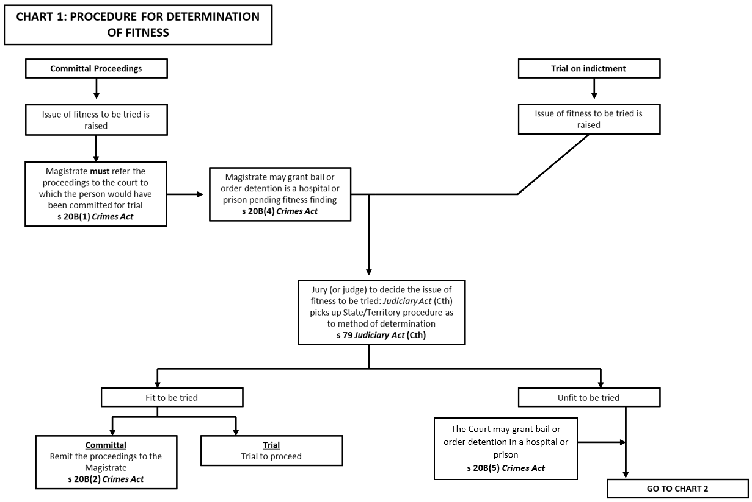

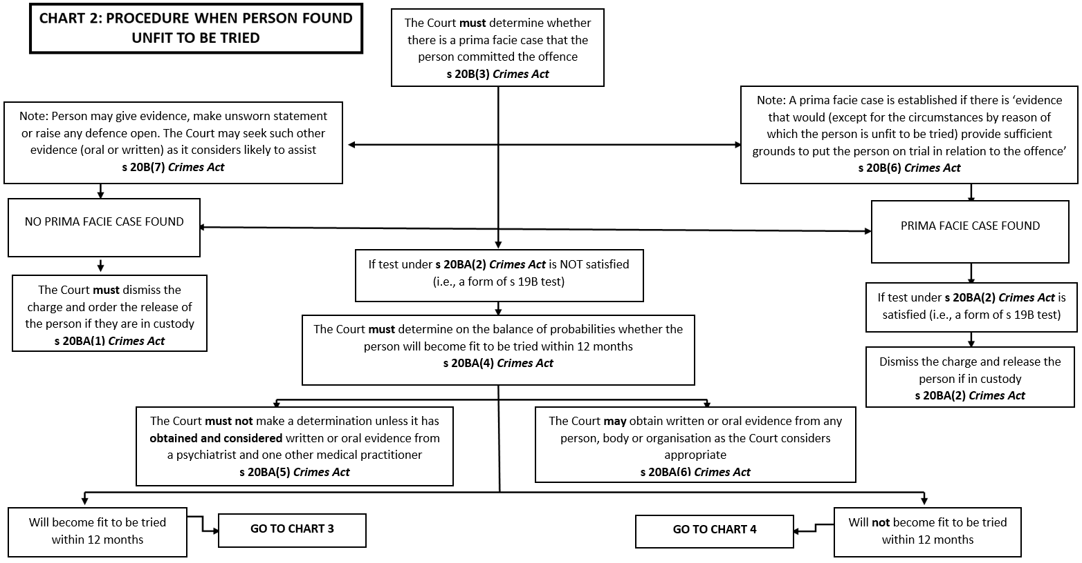

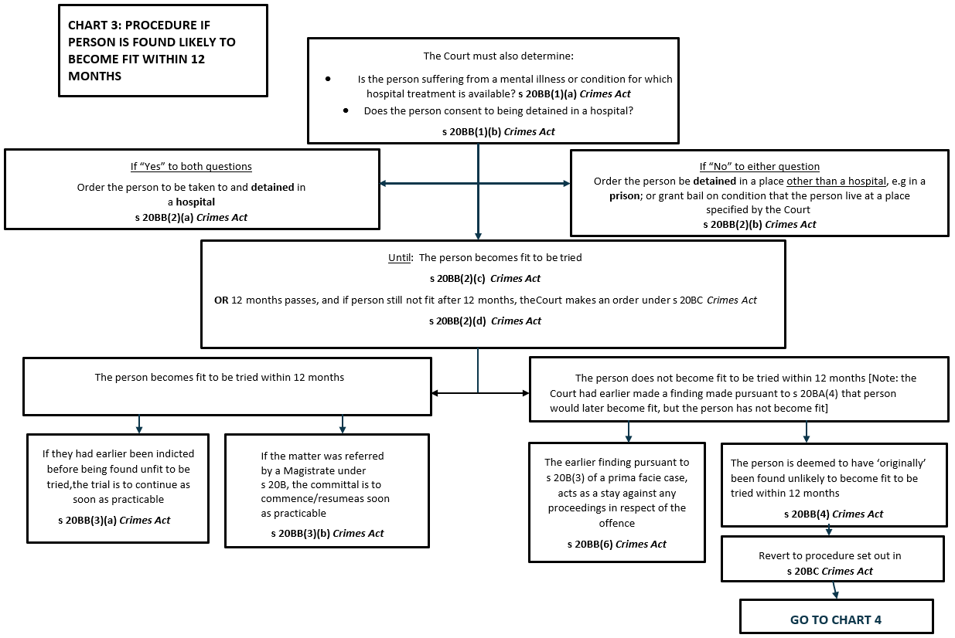

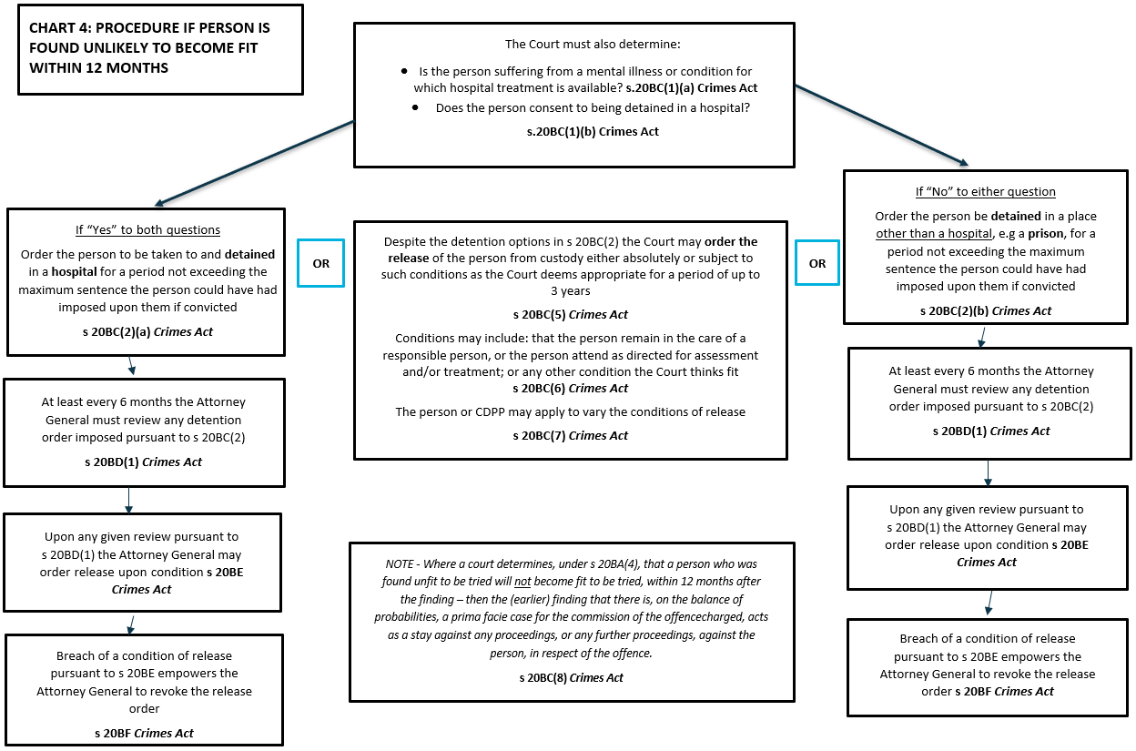

1. *Crimes Act 1914* (Cth) (*‘****Crimes Act****’*) s 16.
2. Ibid ss 20BQ-20BR.
3. Ibid ss 20B-20BI.
4. *R v Mailes* [2001] NSWCCA 155.
5. In *Ebatarinja v Deland* (1998) 194 CLR 444 (‘***Ebatarinja v Deland***’), the High Court stated that proceedings such as committals cannot occur where a person is in a coma
6. See ibid, the High Court indicated that in the Northern Territory a deaf mute with no ability to communicate could not legally be the subject of committal and that the issue of the appellant's fitness to plead was to be determined under the provisions of the *Criminal Code* (NT).
7. *R v Sexton* (2000) 77 SASR 405, [37]–[40].
8. *Kesavarajah v The Queen* [1994] 181 CLR 230, 243 (‘***Kesavarajah***’); *R v Ogawa* [2009] QCA 307; *R (Commonwealth) v Sharrouf (No 2)* [2008] NSWSC 1450 (‘***Sharrouf (No 2)****’*).
9. All references in this NLD are to a ‘person’, as opposed to the ‘defendant’ or ’accused’. This is consistent with the language used in Part IB of the *Crimes Act* (‘person’).
10. However, Prosecutors should always consult their Prosecution Team Leader or Branch Head for guidance where the question of fitness arises at committal. Note also that the Decision Making Matrix decisions to discontinue the proceeding after committal (DMM 4.6), and approval to retain an expert witness (DMM 4.22), may be relevant.
11. This includes after conviction and prior to sentence. However, once the court is *functus officio* of the proceedings, the question cannot be raised. Also note that, where there has been no issue of the person's fitness to be tried at trial, an appeal court will generally not entertain such a ground. See, eg, *Eastman v The Queen* (2000) 203 CLR 1 (‘***Eastman***’).
12. See *Kesavarajah* (n 8) 245.
13. *Crimes Act* (n 1) s 20B(1).
14. For example, in Victoria the judge must find that there is a ‘real and substantial question or issue’ as to the person’s fitness, before a jury can be empanelled to decide fitness. The purpose of this threshold test is to prevent matters where there is no real issue of fitness to be tried at play, from unnecessarily proceeding to full fitness hearing before judge or jury.
15. In *Eastman* (n 11), the Court considered Australian Capital Territory procedure. However, the Court also referenced the national approaches to the question of fitness.
16. *Mental Health and Cognitive Impairment (Forensic Provisions) Act 2020* (NSW) s 42.
17. This due to the effect of *Judiciary Act 1903* (Cth); See generally *Kesavarajah* (n 8).
18. For example, the *Crimes (Mental Impairment and Unfitness to be Tried) Act 1997* (Vic) and the *Mental Health (Criminal Procedure) Act 1990* (NSW).
19. [1958] VR 45 (‘***Presser***’).
20. **NSW:** *Mental Health and Cognitive Impairment (Forensic Provisions) Act 2020* (NSW)pt 4 – the criteria in which a person is determined to be unfit is set out in s 36. **Vic:** *Crimes (Mental Impairment and Unfitness to be Tried) Act 1997* (Vic) pt 2 - the criteria for unfitness are set out in s 6. **Qld:** *Criminal Code 1889* (Qld) ss 613, 645 – the criteria for unfitness are not defined in the legislation, and must be determined by reference to the common law. **WA:** *Criminal Law (Mentally Impaired Accused) Act 1996* (WA), pt 3 – the criteria for unfitness are set out in s 9. **SA:** *Criminal Law Consolidation Act 1935* (SA) pt 8A – the criteria for unfitness are set out in s 269H. **Tas:** *Criminal Justice (Mental Impairment) Act 1999* (Tas) pt 2 – the criteria for unfitness are set out in s 8. **ACT:** *Crimes Act 1900* (ACT), divs 13.2, 13.6 – the criteria for unfitness are set out in s 311. **NT:** *Criminal Code Act 1983* (NT) sch 1 pt IIA – the criteria for unfitness are set out in s 43J.
21. There is a requirement for a spend approval to be created by the prosecutor, and approval to be made by a person at the relevant position level as set out in the Financial Delegations Matrix.
22. Where a psychological report cannot be gained because of a person’s refusal to be assessed, see *R v Rai* [2011] QCA 64. In that matter, the Court was thwarted from determining fitness due to the person’s behaviour, therefore the person was held to be fit to plead.
23. *R v Donovan* [1990] WAR 112.
24. See *Presser* (n 19) 50, where this scenario occurred: ‘The Crown wants a finding that he (the person) is fit to be tried; and I think the appropriate thing is for the Crown to begin’.
25. See *Kesavarajah* (n 8) 242, for discussion by the High Court as to which references to the ‘Court’ in pt IB div 6 mean ‘judge’, and which references mean ‘jury’.
26. Note that in New South Wales and the Northern Territory this will be the Local Court, rather than the Magistrates Court.
27. *Sharrouf (No 2)* (n 8) [51].
28. In *Kesavarajah* (n 8)*,* the court determined that the first reference to a ’court’ in s 20B(3) refers to a jury, however the second reference to ‘court’ refers to a judge.
29. *Sharrouf (No 2)* (n 8) [49].
30. Ibid [55], [68].
31. Ibid [47].
32. Note that this requires an identical test to s 19B of the *Crimes Act* (being a provision of the Act relating to non-conviction dismissal).
33. See General Fact Sheet, ‘After Court/Entering Court Outcomes’.
34. Note that s 20BQ is not a summary ‘fitness to plead’ provision. However, it comprises the summary procedure for a person suffering from a mental illness or intellectual disability at the time of a s 20BQ application.
35. *Morrison v Behrooz* [2005] SASC 142 (‘***Morrison v Behrooz****’)*; *Boonstoppel v Hamidi* [2005] SASC 248 (‘***Boonstoppel v Hamidi***’).
36. See *DPP v El Mawas* (2006) 66 NSWLR 93 and the cases cited there. In *DPP v Seymour* [2009] NSWSC 555, Simpson J found it unnecessary to decide whether *Morrison v Behrooz* (n 35) was correctly decided on this point.
37. In *Boonstoppel v Hamidi* (n 35) [44], Gray J accepted that a s 20BQ disposition was appropriate, despite there have being no finding as to fitness.
38. In *Potts v Bonnici* [2009] SASC 199 (‘***Potts v Bonnici***’), the earlier Magistrates Court had considered step 2 of the s 20BQ test by looking at the state of mind of the person at the time of her offending – i.e., considering whether the defence of mental impairment was available.
39. Refer to the Decision Making Matrix, decision 2.28 – ‘approval to retain expert witness’, and refer to the Financial Delegations Matrix which covers approval for expert witness expenditure.
40. For example, the *Crimes (Mental Impairment and Unfitness to be Tried) Act 1997* (Vic) and the *Mental Health (Criminal Procedure) Act 1990* (NSW).
41. *Boonstoppel v Hamidi* (35) [30].
42. *Boonstoppel v Hamidi* (n 35); and *Potts v Bonnici* (n 39).
43. [2008] NSWCA 213.
44. See the discussion in the *Sentencing of Federal Offenders in Australia: A Guide for Practitioners* (6th edition, April 2023) [1351]-[1352].
45. In *Boonstoppel v Hamidi* (n 35), the Prosecution successfully appealed an unconditional dismissal under s 20BQ, and the appellate Court agreed with the Prosecution submission that the offending (intentional escape from immigration detention in the context of a violent, large scale demonstration where the defendant had prior convictions) was too serious for an unconditional dismissal under s 20BQ. Seriousness of the offence and the need for general deterrence are relevant factors to be considered by the Court during a s 20BQ application.
46. Note that orders made pursuant to s 20BQ are not a ‘sentence’ however CaseHQ refers to them as a ‘penalty’. For full details on how to correctly select ‘plea’, ‘outcome’ and ‘penalty’ for s 20BQ matters, please contact the CaseHQ Help Desk. Also see General Fact Sheet, ‘After Court/Entering Court Outcomes’.